FOR THE PRESS
The Audio-Guide to the Hermitage application was designed specially for the iPhone
Now you can take fascinating walks around one of the world’s largest museums, find out about its history, its artistic masterpieces and splendid palatial interiors with all the necessary information provided on your iPhone and iPad. The Audio-Guide to the Hermitage is your personal interactive conducted tour.
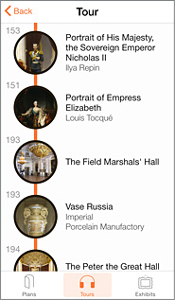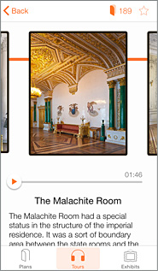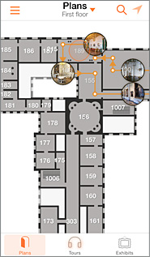
General and thematic excursions created by the museum’s specialists will help you to organize your visit sensibly in accordance with your own interests. The interactive routes that the app can produce at your request will enable you to find your way easily around the more than 300 rooms of the main museum complex.
The app includes:
- interesting general and thematic excursions
- detailed floor plans showing the location of specific exhibits and museum facilities (cafés, information kiosks, ATMs. WiFi zones, etc.)
- enlarged views of individual rooms showing the location of exhibits
- calculation of the shortest route to your object of interest
- a catalogue of the Hermitage’s masterpieces
- information about the museum and ticket prices

The app comes in English and Russian versions.
At present the following excursions are available:
- The Hermitage in an Hour
- The Hermitage. Large General Tour

New excursions will be added to the range regularly.

